**Linux Installation using**

**Virtual Box Manual**

ACTIVITY 2 OUTPUT

**System Administration and Maintenance**

**GELIL DAVID S. GALANG**

Instructor

Submitted by:

**MCKINLEY CAMACHO**

**Introduction.**

Linux is a family of operating systems based on the Linux kernel, the core of an operating system. It enables the communication between hardware and software components. Linux is based on Unix and built around the Linux kernel. It was released in 1991 and is available for web servers, gaming consoles, embedded systems, desktops, and personal computers. It comes in many different versions called distributions. Linux® is an open-source operating system (OS). An operating system is the software that directly manages a system's hardware and resources, like CPU, memory, and storage. The OS sits between applications and hardware and makes the connections between all your software and the physical resources that do the work.

Ubuntu is a Linux distro based on Debian. It is suitable for cloud computing, servers, desktops, and internet of things (IoT) devices. The main difference between Linux and Ubuntu is that the former is an operating system family based on Unix, while Ubuntu is a Linux distribution. Ubuntu was introduced in 2004 by a British company Canonical. It was based on Debian a popular distro back then, which was difficult to install. As a result, Ubuntu was proposed as a more user-friendly alternative.

**Objectives**

There are many reasons why Linux should be preferred over proprietary software platforms such as Windows and Mac. Linux has today become user-friendly enough to replace Windows on desktops. Linux ought to be adopted by home users, educational institutes, and businesses. Installing and using Linux on your system is the easiest way to avoid viruses and malware. The security aspect was kept in mind when developing Linux and it is much less vulnerable to viruses compared to Windows. All of us know that with every new release of Windows OS, a huge number of hardware systems become obsolete as their technical specifications are no longer adequate to run the latest Windows OS. Linux makes very efficient use of the system’s resources. Linux installation can be customized for users and for specific hardware requirements. The installation procedure is very flexible and allows users to choose the modules they want to install.

Linux is completely free, and users do not need to pay for anything. All the basic software required by a typical user and even an advanced user is available. This is the most useful aspect for students, as they can use the software to study how it works, before modifying and extending the code to suit their needs. This will also help them to learn the internals of an OS and the software. This process will help in the development of new software and aid innovation based on local needs.

**Body**

**Steps by Step Procedures installing the Operating System in Virtual Box**

1. 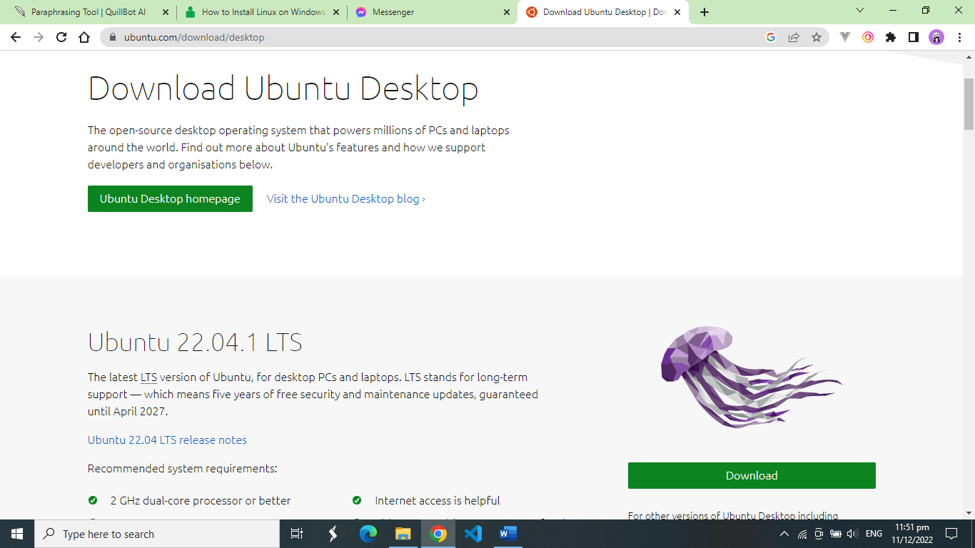**Download ISO for Ubuntu and Virtual Box**

* **Start by downloading the ISO for Ubuntu. *All you need is the ISO as you're installing Ubuntu using VirtualBox. It’*s ideal to use the LTS (long-term support) version. The LTS version in use right now is Ubuntu 20.04.2 LTS.**

* You’ll need to [download](https://www.virtualbox.org/wiki/Downloads) and install VirtualBox on your PC. You can download the Windows package, but there are packages available for Linux and macOS as well.

1. **Configure Virtual Box for Ubuntu**

* Graphical user interface, text, application

  Description automatically generatedYou’ll see the following welcome screen when you launch VirtualBox. Click on **New** to begin the configuration process.

A dialog box should pop up. Next, follow these steps:

* Give your Virtual Machine a **Name**, for instance, Ubuntu v20.04.2 LTS.
* Click on the drop-down menu besides **Type**and select **Linux**.
* Graphical user interface, text, application, chat or text message

  Description automatically generatedChoose the **Version**as Ubuntu (64 bit) or Ubuntu (32 bit).
* Allocate **Memory size** to your virtual machine. Ideally, you should choose to allocate about a fourth of your PC’s RAM. For instance, if you have 16GB total RAM, allocate 4GB to the virtual machine.
* 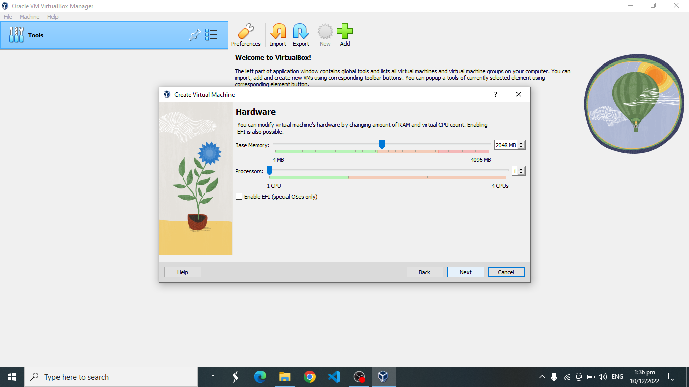Select the **Next**button.

You’ll also need to allocate a portion of your hard disk to the virtual machine. This portion will only be accessible to your virtual operating system, i.e., Ubuntu in this case. You have two options to choose from; you could either use **Dynamically allocated** storage which grows as you keep using the storage or allocate a **Fixed-size** storage limit that offers faster performance.

* On the next screen, you’ll need to create a new hard disk for your virtual machine. Choose the **Create a virtual hard disk now** option and click **Create**.
* Choose **VDI (VirtualBox Disk Image)** and select **Next**.
* Choose **Dynamically allocated** and select **Next**.
* You’ll see the default VDI storage location and size on the next screen, leave them as they are, and select **Create**.

This completes the first part of the configuration process. Our virtual machine has been set up, so let’s now move forward and add the Ubuntu ISO to the virtual machine. Before moving forward, ensure that you have hardware virtualization enabled in your bios settings. If it’s not enabled, the next steps will not work. You’ll now see Ubuntu listed on VirtualBox’s left sidebar. Select it and click on **Settings**.

Look for **Storage** on the left sidebar of the **Settings** dialog box. Click on the tiny disc icon in the **Attributes** section, select **Choose a disk file**, navigate to the ISO, and select **OK**.

1. **Begin Ubuntu Installation**

* 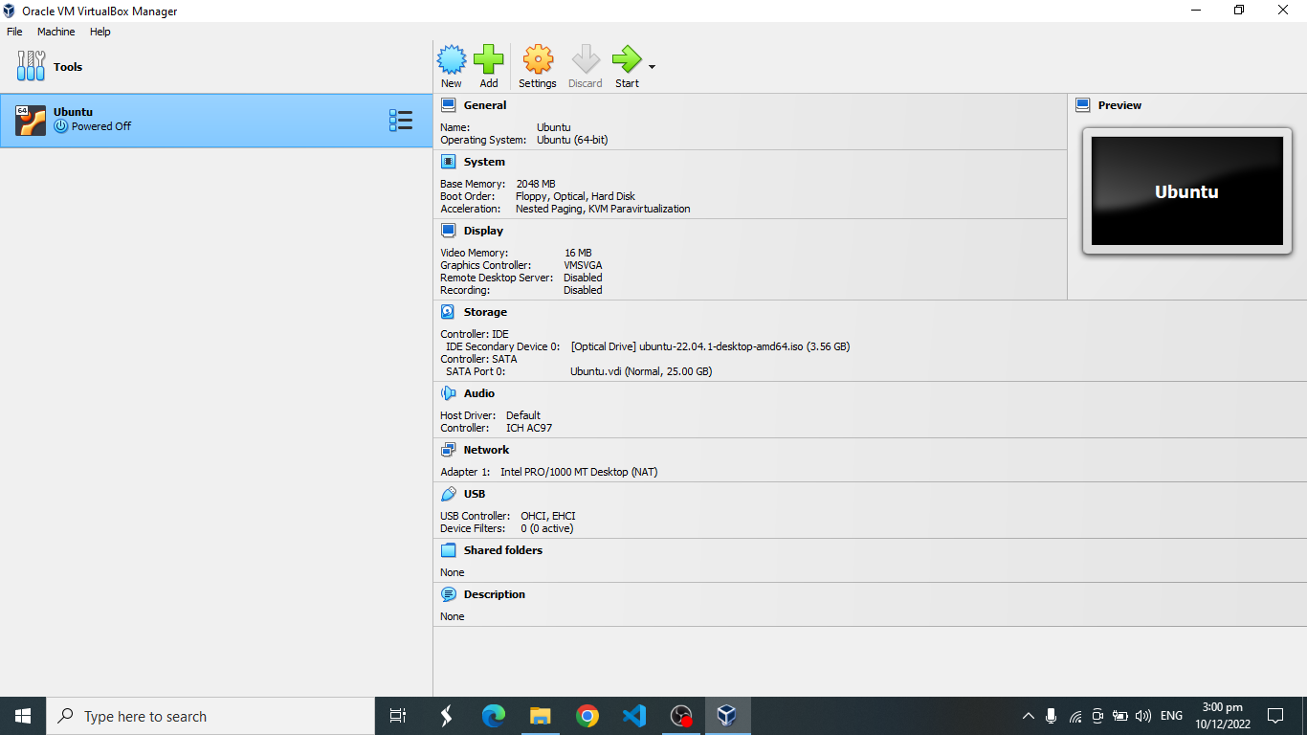Start by clicking the **Start**button on the VirtualBox home screen. Select the Ubuntu ISO as the start-up disk in the dialog box that pops up and select **Start**.
* You’ll see the machine initiate the process. This may take a few minutes.

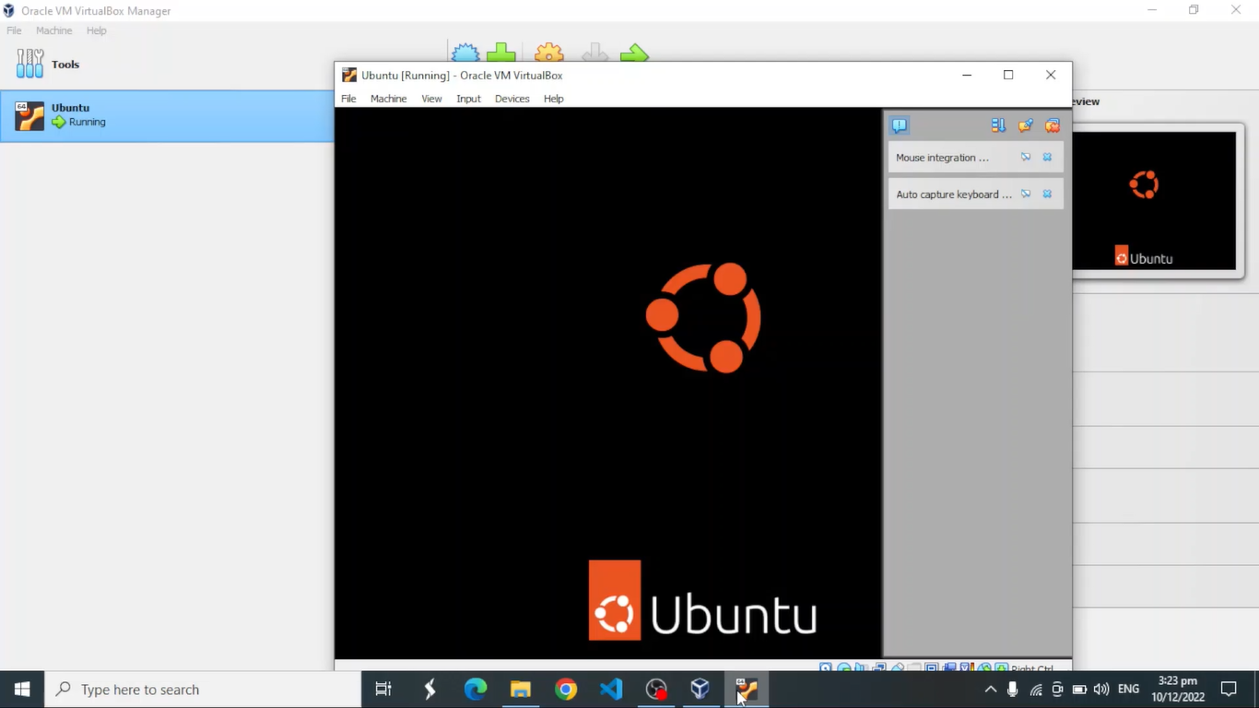

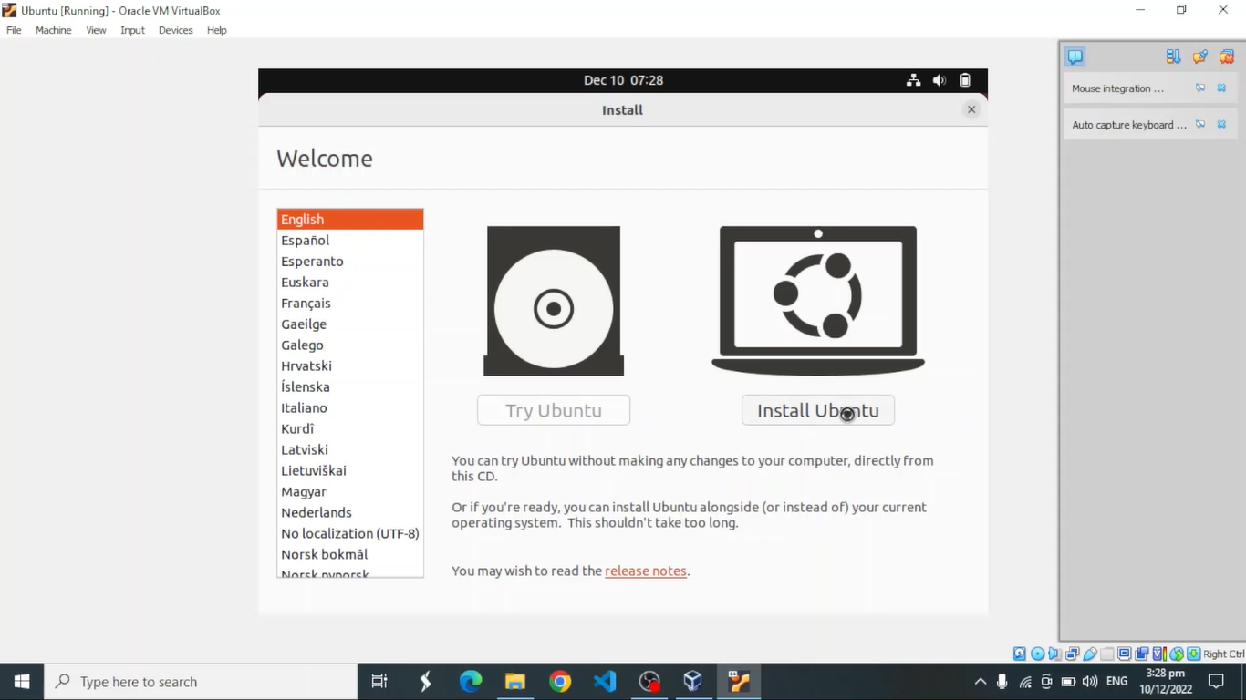

* You have two options at this point. You could either **Try Ubuntu** before you move forward with the installation or **Install Ubuntu** if you feel confident already.
* If you choose **Try Ubuntu**, you can start using Ubuntu right away. Alternatively, you could choose to **Install Ubuntu**.

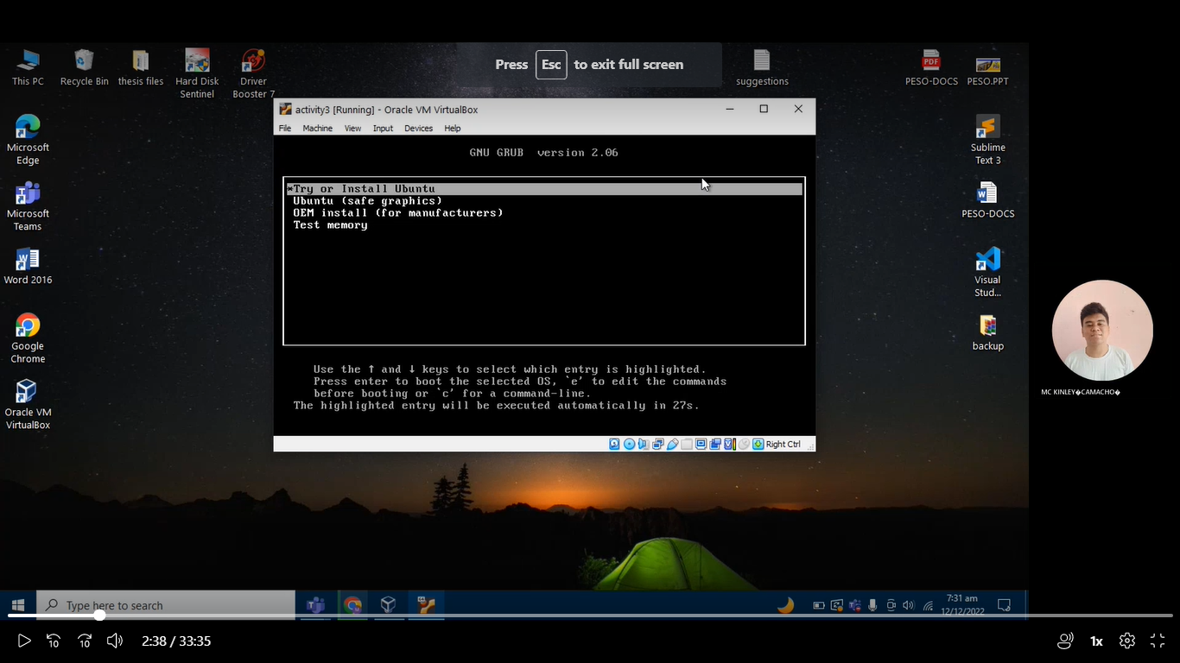

* Before installing Ubuntu, remember that you can use it like any other operating system, but you can’t store any data on a virtual machine. Every reboot is a fresh start with no data preserved from the previous session.
* If you’ve chosen to move forward with the install option, select **Install Ubuntu** to initiate installation.
  1. Choose your preferred **Keyboard layout**.
  2. Keep following the installation wizard’s prompts. You may be asked if you want to **Erase disk and install Ubuntu**. This is normal, just select **Install Now**and move forward.
  3. Next, you’ll be asked to choose your region. Select your region and select **Continue**.
  4. You’ll then be asked to input your details such as your name, computer’s name, username, and password.
  5. 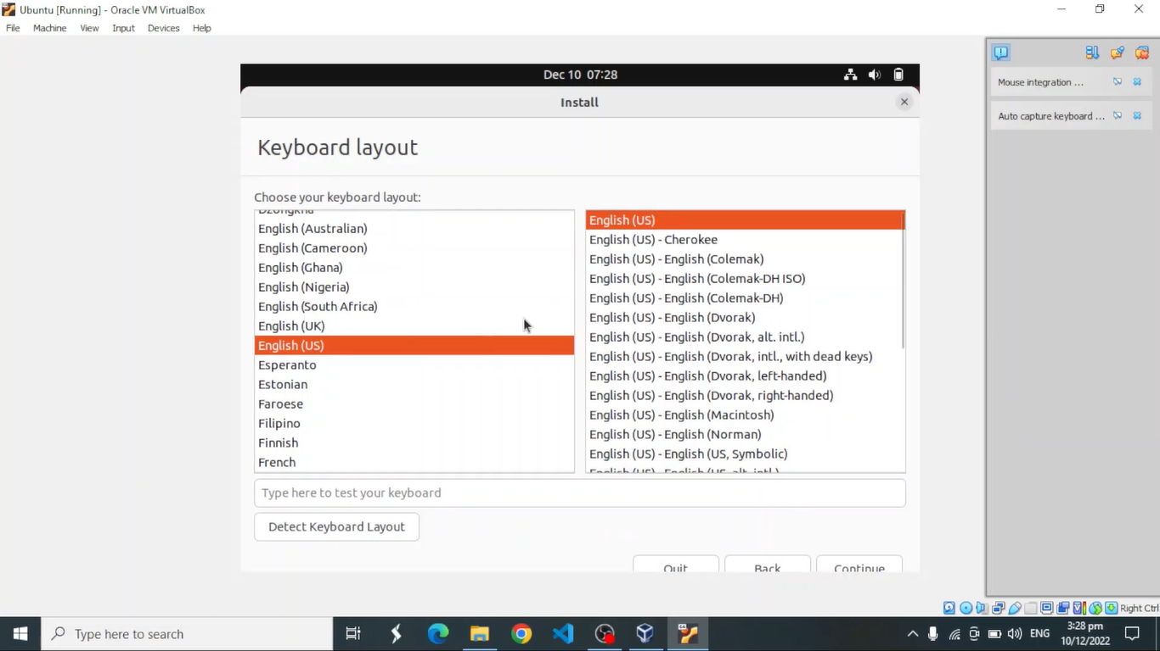Graphical user interface, text, application

     Description automatically generatedThe installation wizard will continue the installation process by itself after collecting the details. This could take a few minutes.
* 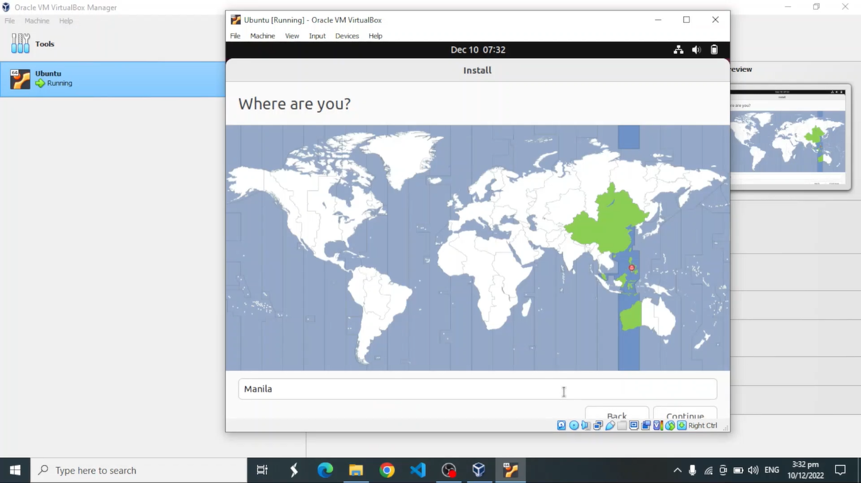When the installation completes, your virtual machine will automatically reboot. Run the virtual machine again, and it should boot into Ubuntu.

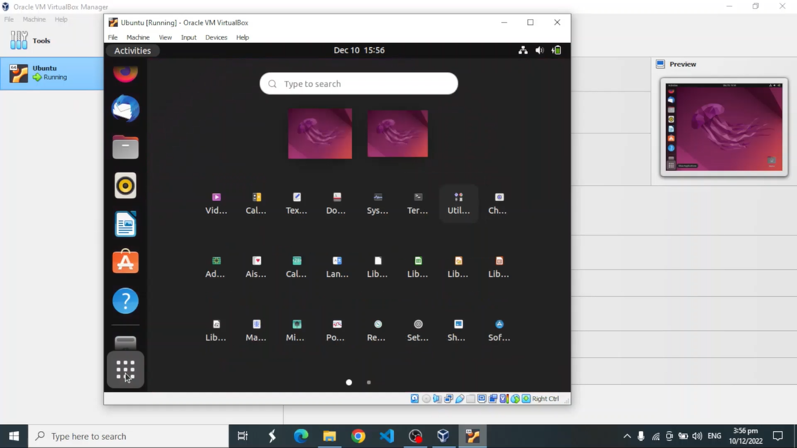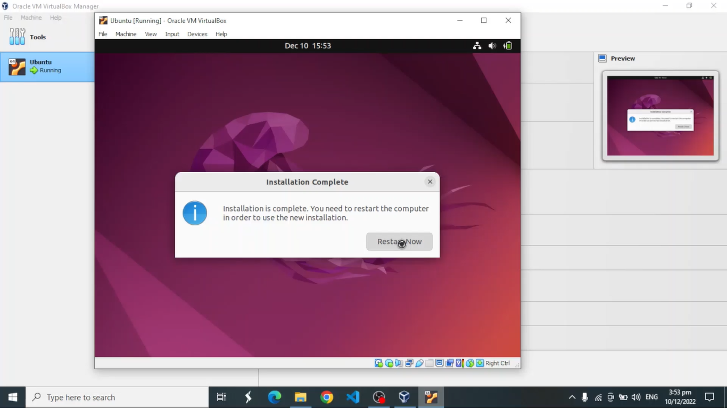

**Advantages for Linux Operating System**

* Highly Secure
* Stable
* Free and Open Source
* Easy to use
* Absolute Freedom over your system
* High Performance
* Proper use of System Resources
* Privacy-Friendly
* Easily Install Software
* Better Software Updates

**Disadvantages for Linux Operating System**

* No standard edition
* Hard Learning Curve
* Limited market share
* Lack of proprietary software
* Difficult to troubleshoot
* Poor support for games
* Unsupported Hardware
* Lack of technical support
* No hibernation
* No unified installer/package manager

**Summary**

Oracle VM VirtualBox is a free and open-source hypervisor program that allows users to create virtual machines and run different operating systems on one machine. One of the most common uses is for running Linux. This lesson shows how easy it is to install Linux guests on VirtualBox hosts. You can also start up a virtual machine and continue to use your regular operating system.  For this lesson, we'll use Ubuntu. The process is identical for other Linux distributions. You simply download the Ubuntu iso image from the official website and run through the installation process in VirtualBox. Linux installation is not too difficult. During installation, Linux is installed in accordance with the choices made previously and will display the choices you made prior to installation for you to confirm these and, optionally, modify them prior to installation occurring.

The last step in the installation stage prepares your system to boot into the new Linux operating system, which includes copying of the system files to the system, saving any system configurations, installing the Boot Manager, saving any installation settings, and finally preparing the system for the initial boot.